Report of Quiz Competition 4th April, 2023
Department of Zoology
B.N. College, Dhubri

Class wise Quiz Competition for the Zoology Honours students (2nd and 4th semester) held on 4th April, 2023 at the 35 no Class Room of the College. Dr. Bhabesh Nath, Assistant Professor, Department of Zoology acted as the Quiz master in the programme.
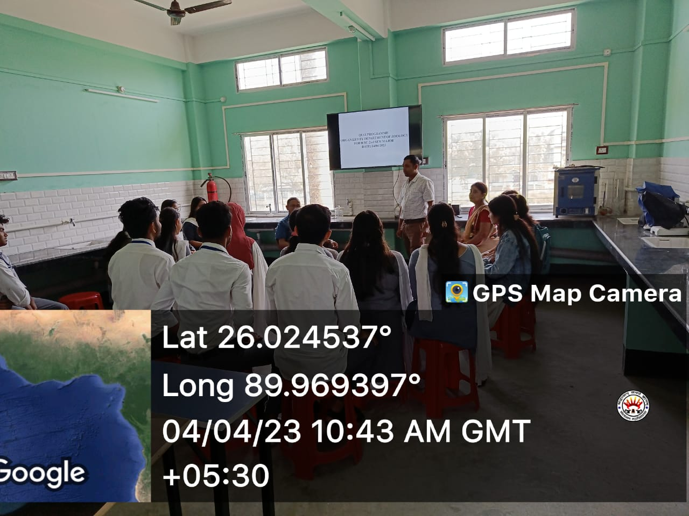
2nd Sem (Major) quiz photograph

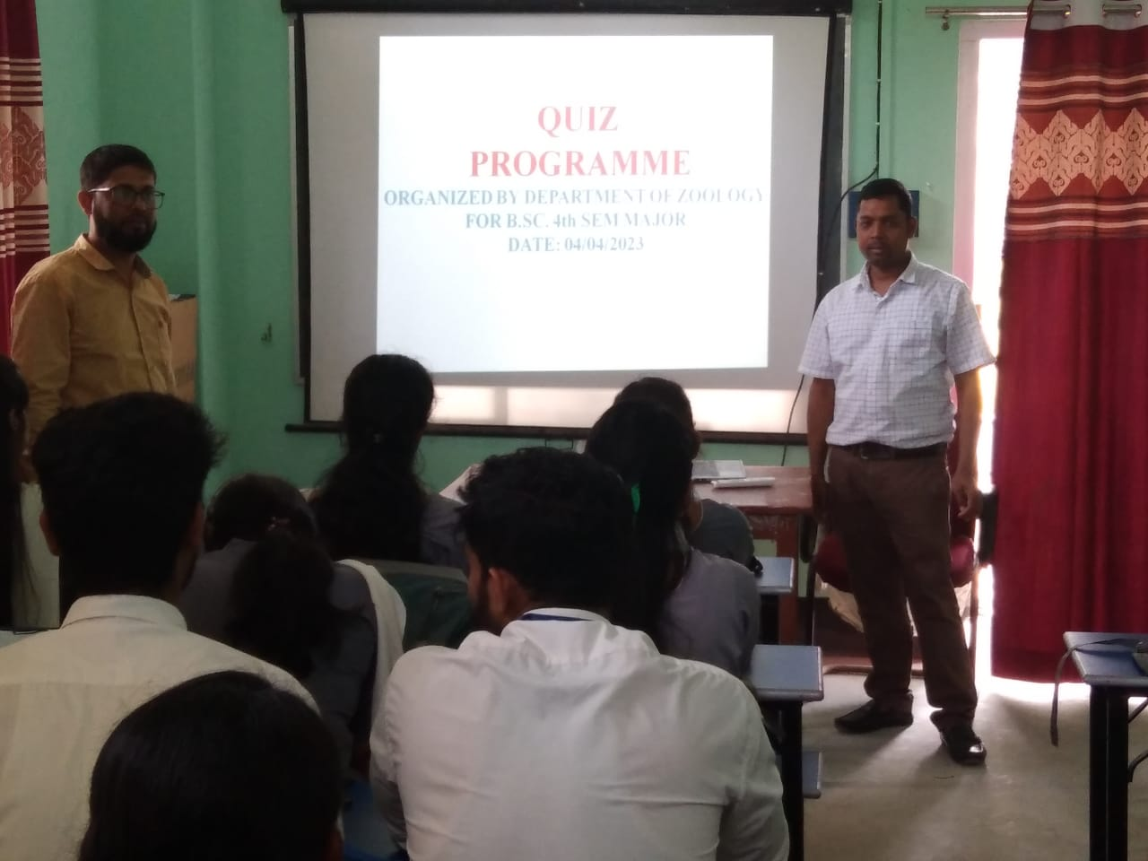
4th sem (Major) quiz photograph
Mrs. Mitali Ghosh Paul and Nasima Akter, all Assistant Professors of Department of Zoology were in the Score Table of the quiz assisting in preparation of Score Sheet of the programme.
The programme started with the Quiz for Zoology Honours 2nd Semester. There were 3 numbers of rounds including a visual round. The members of the Winner team of the quiz were Deep Pramanik ( Roll No. 160) , Sampoorna Bhardwaj (Roll No. 427) , Debjyoti Adhikary (Roll No. 104), Mokleswar Rahman (Roll No. 174).
Finally, The Quiz for Zoology Honours 4th Semester was held. There were 3 numbers of rounds including a visual round. The members of the Winner team of the quiz were Manisha Saha (Roll No. 28), Rinki Saha (Roll No. 95) and Amit Paul (Roll No. 93).

Attendance of students
